## PRACTICAL NINE: EXPLORE THE DESCRIPTIVE STATISTICS OF SPSS

These are the following steps to follow in order to get the descriptive statistics of a data.

STEP 1: Input your data or Import data from other source

STEP 2: From the menu select Analyze, then proceed to clicking descriptive statistics

STEP 3: Select frequencies, then it brings you to a dialog box. Then you click and drag variables in question from the left box to Variable(s).

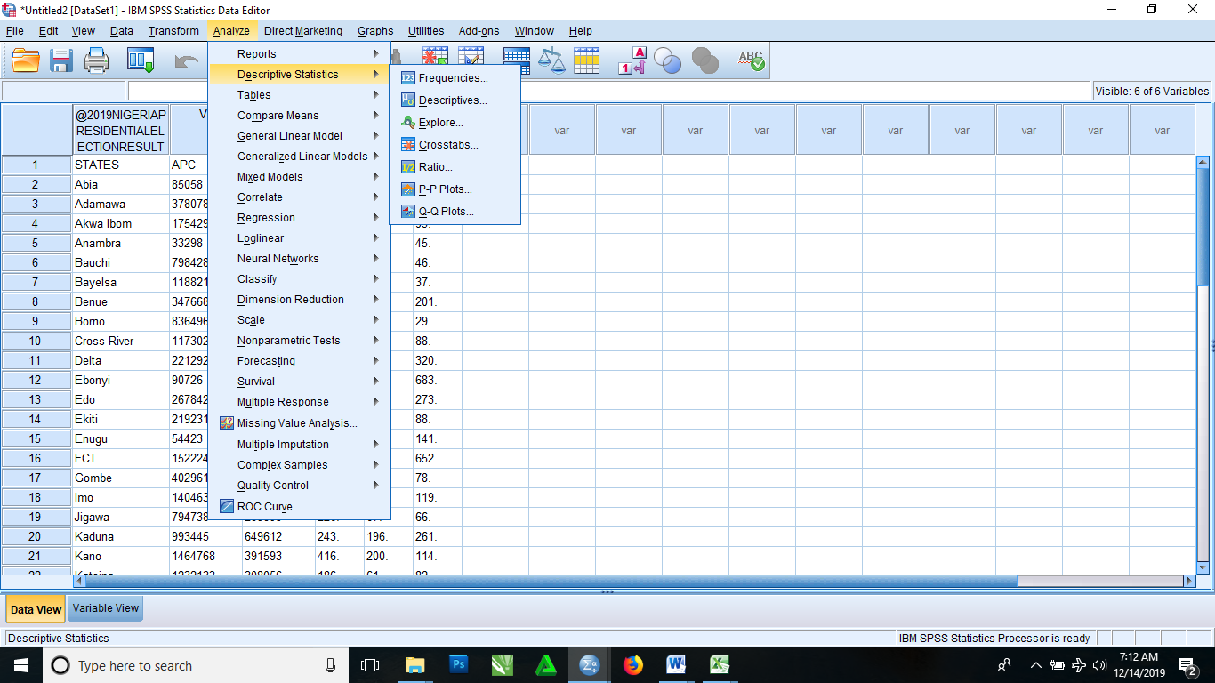

STEP 4: Then click on the statistics tab, it then brings you to a dialog where you have to select every options aside from Percentile(s). Then you click on continue, it then brings you back to the previous frequencies dialog box

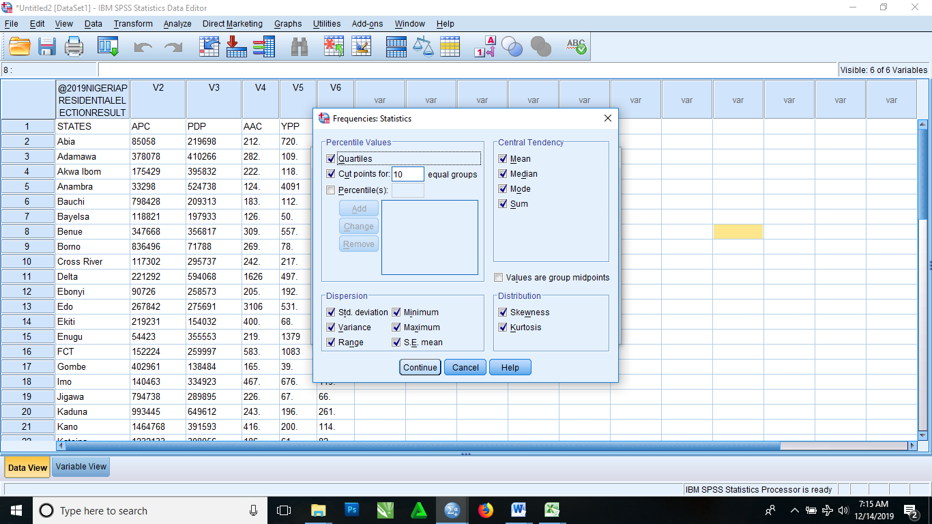

STEP 5: Click OK. It then brings out a result in this format below

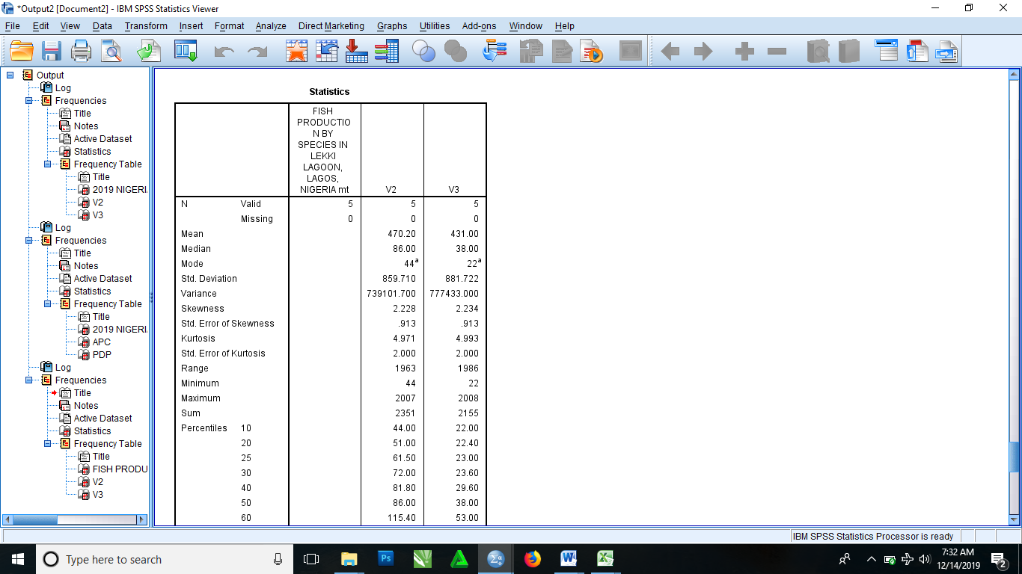

Now to get the descriptive

STEP 1: From the menu bar again you click on Analyze, then select descriptive statistics and it takes you to another field of options and click on descriptive.

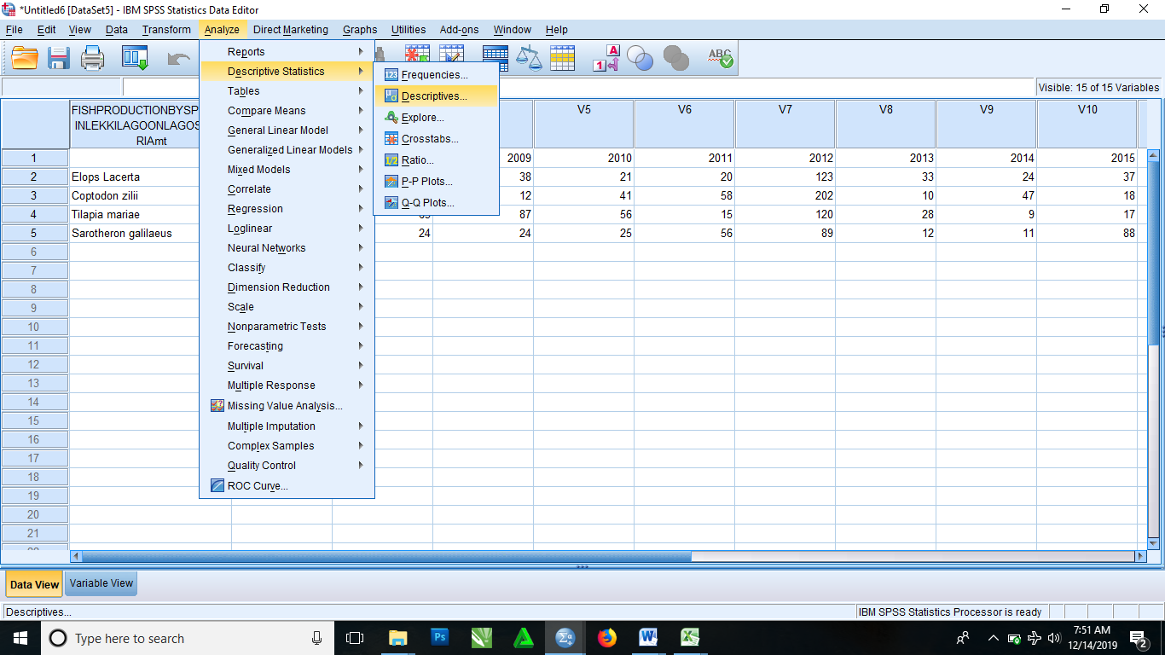

STEP 2: It then brings you a dialog box where you click and drag the variables in question from the left box to the right empty box.

STEP 3: Click options to select the parameters, then click continue. It then brings you back to the descriptive dialog box

STEP 4: Click OK.

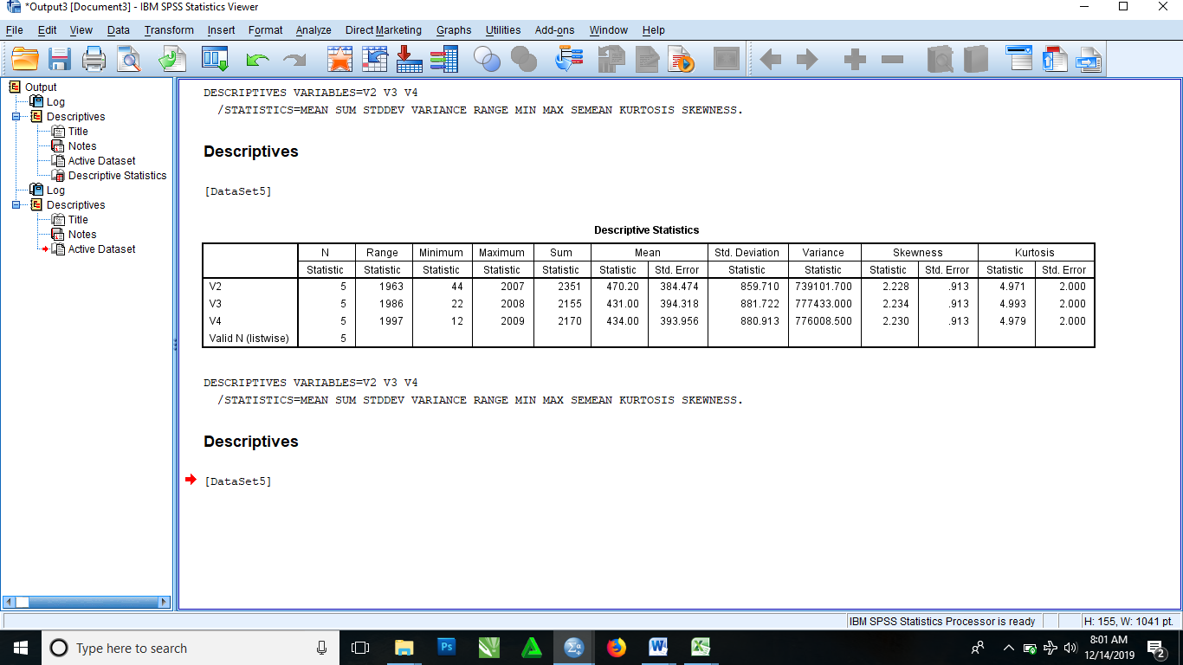

Now to get the Crosstabulations

STEP 1: From the menu bar select analyze, then select descriptive statistics and it bring an option of choices, you then select Crosstab

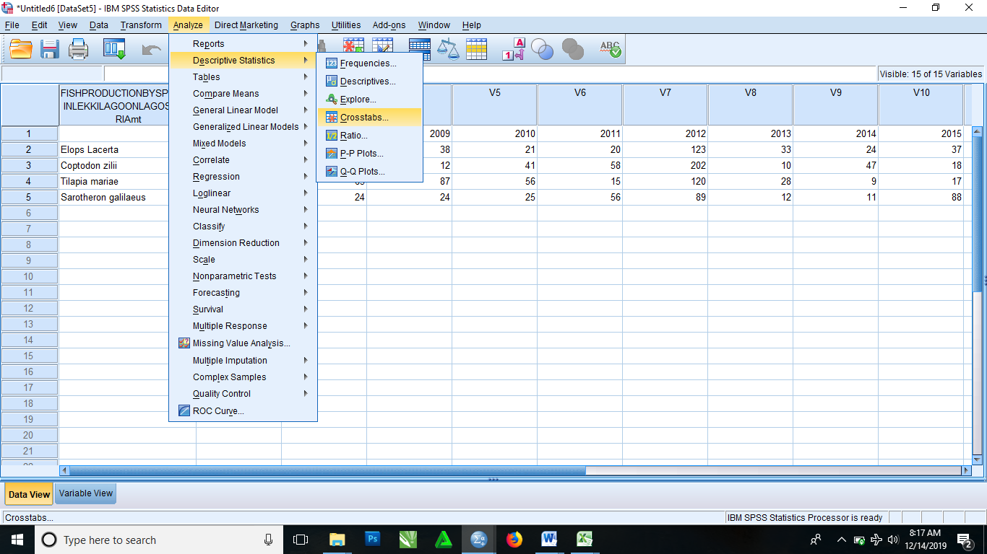

STEP 2: It then brings you to Crosstab dialog box where you click and drag the variables in question from left box to each of the Row(s) box and Column(s) box on the right

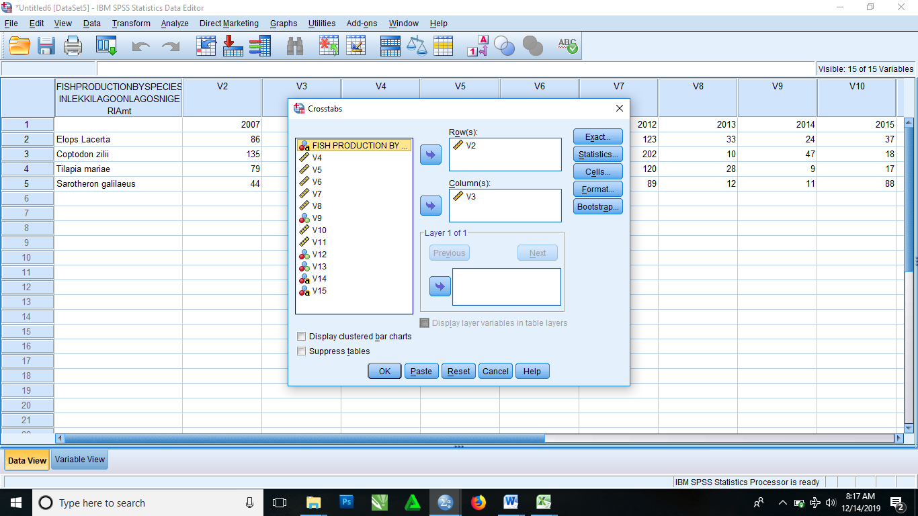

STEP 3: Click OK

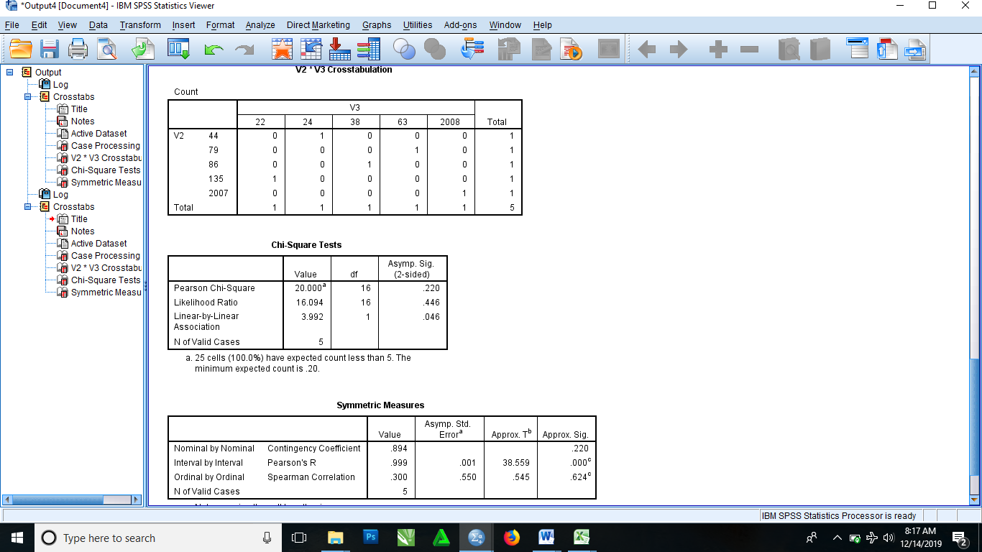

To get the Ratio Statistics

STEP 1: From the menu bar select analyze, then select descriptive statistics and it brings an additional option where you then select Ratio

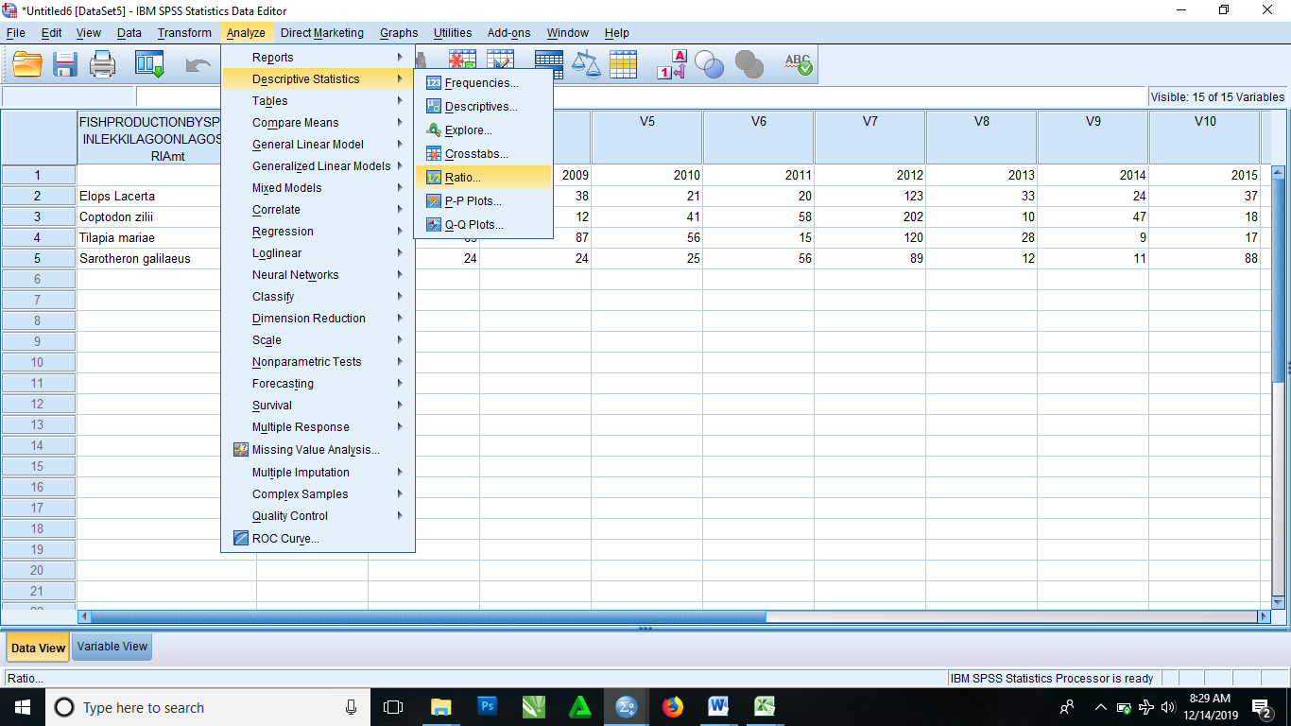

STEP 2: It then brings Ratio statistics dialog box. Then you click and drag the variables in question from the left box to the right box with consist of the Numerator, Denominator and Group Variables

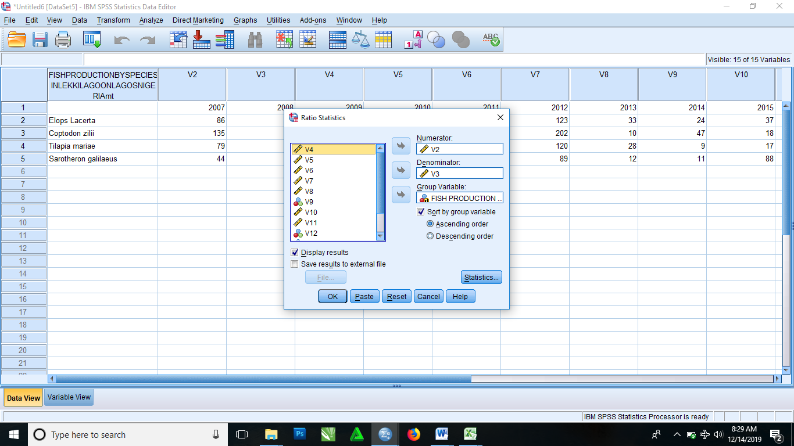

STEP 3: Click OK.

